ONLINE BANKING

Technical Design Document:

**INTRODUCTION & OBJECTIVES**  
The main objective of the proposed solution is to be automated the various functions and activities of the bank through Internet. The solution will facilitate to the bank employees and the account holders with the different modules. This solution is very much necessary for the private sector banks and the corporate sector. The banking industry will take a new shape and explore like never before. Using the solution, the bankers and account holders can generate various kinds of reports.   
  
**BUSINESS REQUIREMENTS:**  
**Searching Capabilities:**For the account holder’s convenience and on hand information, this solution provides certain searching and checking features for his account. The account holder can any time and any number of times can log on and search for various details as the account’s balance, details of transactions etc. The account holder will have his unique id and password for logging on to the account’s information.  
**User friendly:**  
The solution provides very simple and modified features, which are very easy to view and operate various features. The said project is designed and organized in very simplified manner to suit the current requirements of the account holders of various models such as Saving Bank Account, Current Account and Recurring Deposit Account.  
**Scope**

The Application Design outlined in this document builds upon the scope defined in the Requirements phase

# **High Level Design Overview**

There are two views of this Online Bookshop:

ADMINISTRATOR VIEW:

The administrator controls the all online banking activities. The admin also has a username & password through which he enters in the admin view.It has the following :

* **Add, Update & Delete a customer**: The admin can add or delete a customer according to the needs of the website or the users.
* **Add, Update & Delete a Book**: Admin can add or delete a customer.
* **Logout**: In the login page admin will move the login page.

USER VIEW:

It contains following:

* **Login**: The user can login using the username and password it has registered with. After login, the user can do transactions.
* **Registration**: A new user has to register first until then he cannot transfer money.

**Table Diagram:**

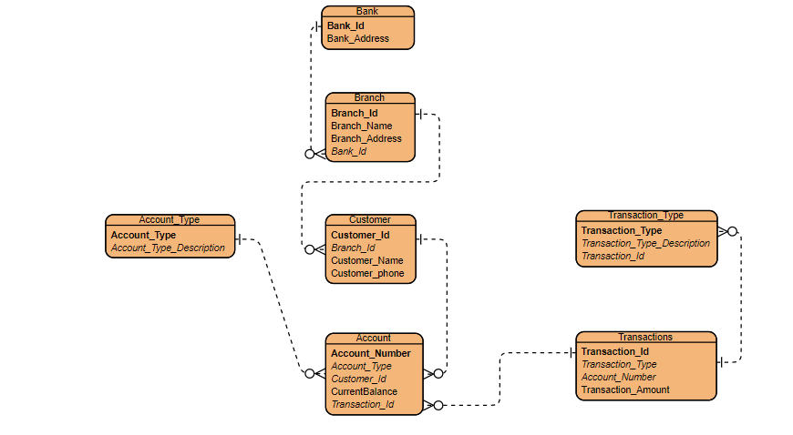

Project Required Document (PRD):

**Access**

1. **Administrator Access**

* Login
* Add, Delete & Update Customers
* Logout

1. **User Access**

* Register
* Update Account
* View Account
* Login
* Logout

**User**

1. **Register**

* **Purpose:** If the user doesn’t have an account then he will be asked to register.
* **Actor:** User
* **Input:** The user will enter details in the registration form according to the required fields. The fields include
* Username
* Password
* Confirm password
* Email
* Address
* Phone
* **Output:** After registration the user will be directed to the main home page

1. **Login**

* **Purpose:** If the user wants to get access to all the functionalities of Online Banking, he/she should login using his username and password.
* **Actor:** User
* **Input:** The user will enter his username and password.
* **Output:** If it is a successful login the user will be directed to the main home page. Else if the user enters invalid information, he will be asked to check the entered information.

1. **Update Profile**

* **Purpose:** If the user wants to change his personal account information then he can update his selected fields and the entire data will be updated in the data base through an update query.
* **Actor:** User
* **Input:** The user will update his account information.
* **Output:** The system will update the entered information in the database using an update query.

1. **Logout**

* **Purpose:** If the user wants to end his session and sign out of the website then he can use the logout option.
* **Actor:** User
* **Input:** The user will click the logout button.
* **Output:** The user’s account session comes to an end and he should login again if he wants to enter into the website.

1. **Transaction**

* **Purpose:** If the user wants to do transaction then he can place a transaction by selecting transaction type.
* **Actor:** User
* **Input:** The user will enter the amount and click the add to transfer button.
* **Output:** The transaction will be done through customer account.

1. **View Account Balance**

* **Purpose**: If the user wants to view the account details, he can click the account details link at the top of the page.
* **Actor**: User
* **Input**: The user will click the view link at the top of every page.
* **Output**: The customer account details will be displayed in tabular form

1. **Administrator Login**

* **Purpose**: If the Administrator wants to get access to all the functionalities of Online Banking, he should login using his username and password.
* **Actor**: Administrator
* **Input**: The Administrator will enter his username and password.
* **Output**: If it is a successful login the Administrator will be directed to his menu page. Else if the Administrator enters invalid information, he will be asked to check the entered information.

1. **Add, Delete & Update Customer**

* **Purpose**: If the Administrator wants to add or delete a Customer then he can insert or delete a customer using his administration rights and the customer table will be updated in the database.
* **Actor**: Administrator
* **Input**: If the Administrator wants to add a customer then he should click the insert link button in the customer page else he can delete a particular selected customer
* **Output**: The updated customer list will be displayed in the main home page.

1. **Logout**

* **Purpose**: If the Administrator wants to end his session and sign out of the website then he can use the logout option.
* **Actor**: Administrator
* **Input**: The Administrator will click the logout button.
* **Output**: The Administrator’s account session comes to an end and he should login again if he wants to enter into the website.